**NOTICE OF ELECTION**

**School District of Amery**

**April 01, 2025**

**Election Details**

NOTICE IS HEREBY GIVEN that a school board election is to be held in the School District of Amery on Tuesday, April 01, 2025. The following school board offices are to be elected to succeed the present incumbents listed.

Office Incumbent  
Position at Large Dale Johnson

Position at Large Joe Vierkandt

**Office Terms**

The term of office for a school board member is three years beginning on April 28, 2025 and expiring on April 23, 2028. A description of the school district boundaries can be obtained from the school district office.

**For Candidates**

A Campaign Registration Statement and a Declaration of Candidacy must be filed no later than 5:00 p.m. on Tuesday, January 7, 2025 in the office of the school district clerk, located at 543 Minneapolis Avenue S, Amery, Wisconsin 54001.

**Primary Election**

If a primary is necessary, the primary will be held on Tuesday, February 18, 2025.

Done in the City of Amery on November 26, 2024.

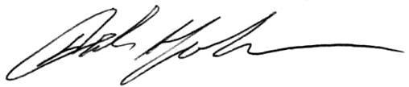

DALE JOHNSON

District Clerk, School District of Amery